**THIS IS A TEMPLATE ONLY AND NOT THE APPLICATION.**
APPLICATIONS MUST BE COMPLETED AND SUBMITTED
ONLINE VIA OUR WEBSITE

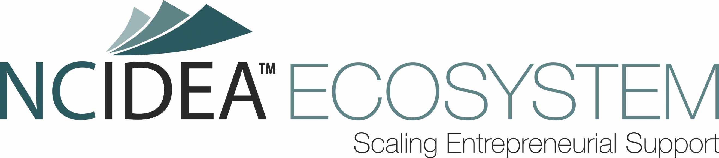

Fall 2022 NC IDEA ECOSYSTEM

Grant Application Template

Organizational Information: Please briefly describe your organization, including your mission, geographic scope and constituents served. (max 2,500 characters)

Audience(s): Based on your mission, which of the following audiences does your organization primarily aim to serve? (multiple options can be selected)
• Students in Universities or K-12 Schools
• High Growth Entrepreneurs
• Entrepreneurs of Color
• Entrepreneurs in Tier 1 & 2 Counties
• Female Entrepreneurs
• Necessity Driven Entrepreneurs
• Other: (open text field)

Stage: What "stage" of entrepreneur does your organization primarily serve? (please select one)
• Idea-stage
• Startup (part-time founder)
• Growth (full-time founder)
• Scaling (founder + employees)

Methods: Which of the following methods does your organization use to support entrepreneurs? (multiple options can be selected)
• Coaching and Mentoring
• Connections and Events
• Knowledge and Training
• Direct Funding
• Indirect Funding Support
• Space and Tools

Team: List the key members of the team that will be involved in executing the proposed program or project. Describe the extent of their involvement and their current role within the organization. Briefly describe each individual’s qualifications and the relevant aspects of their background as it relates to successfully executing the proposed program. (max 1,000 characters)

Proposed Program: Describe your proposed program or project in detail. Is this an existing program or is it new? Be sure to address who this program is targeted to impact, and the geographic scope of the proposed program or project.

Note that programs supported by this ECOSYSTEM Grant are REQUIRED to focus on under-served entrepreneurs in North Carolina. NC IDEA defines under-served entrepreneurs as those that identify as female, entrepreneurs that identify as minority (or persons of color), and/or entrepreneurs that are located in counties designated as “Tier 1” or Tier 2” by the N.C. Department of Commerce. (max 7,500 characters)

For internal data purposes, please also select which of the following under-served entrepreneur groups this proposed project will focus on: (multiple options can be selected)
• Female-founded
• Minority-founded
• Located in a Tier 1 or Tier 2 county

Alignment: How will the projected outcomes of the program further NC IDEA’s vision to help North Carolinians achieve their entrepreneurial ambition to start and build growth-oriented companies? (max 2,000 characters)

Existing Programs: Tell us about any related programs you are conducting or have conducted (if any), and if applicable describe concrete results achieved. As well, note if you are aware of any similar programs that another organization is conducting or has recently conducted in N.C. (max 1,500 characters)

Total Grant Request ($): ________

[Please enter a whole number above. Do not include a dollar sign.]

Grant Request and Budget: Provide a summary of the funds being requested for this grant and how they will be used. List budget items, dollar amounts and projected dates on when the funds will be spent. If you are requesting general operating support, please provide your overall operating budget. If you are requesting funds that would be disbursed to other parties, but those funds would be returned to your organization in some manner, please specifically detail this. Grant requests can be for up to $100,000 in total and paid out over a period between the execution of the Grant Agreement and June 2023, with all funding to be utilized by December 2023. (max 2,500 characters)

Outcomes & Metrics: What are the expected outcomes of the proposed program or project? Be specific about what will constitute success. Describe the milestones and metrics the organization expects to reach if a Grant is awarded. Also describe any outcomes of the program that you highly value but would not necessarily be able to measure. (max 2,500 characters)

Financial Leverage: How are your operations currently funded? To what extent would an award from NC IDEA be leveraged by other funds from your organization (or outside financial contributors)? Will other resources complement the proposed program? (max 1,500 characters)

Sustainability: How do you believe this proposed program will be financially sustained beyond the timeframe of the Grant? (max 1,500 characters)

Impact: Describe how this Grant will impact your organization. What additional milestones would this Grant enable the organization to achieve? Describe the path that the organization would take if this Grant is not awarded. (max 1,500 characters)

Misc: What else should we know about your proposal but failed to ask? (max 1,000 characters)

Disclosure of NC IDEA Involvement
Please list any NC IDEA employee or Board Members that support (previously or currently) your organization through volunteering on board, committees, or through financial contributions. In addition, please indicate the nature of their involvement. (max 2,500 characters)

Recommendation: Did an NC IDEA Employee or Board Member recommend you apply for the NC IDEA ECOSYSTEM Grant? If yes, please list their names below. (max 1,000 characters)

I acknowledge that NC IDEA reserves the right to maintain all information contained in this application. By applying to an NC IDEA Program, I recognize that my email and company demographics may be added to the NC IDEA mailing list and, when appropriate, shared with an exclusive list of NC IDEA Partners. If you do not want to be included on the NC IDEA mailing list or you do not want us to share your information with our exclusive partners, you can opt out by sending an email request to programs@ncidea.org. Please enter your full name below. (Open text field)

Based on the volume of applications, we will not be able to provide feedback or give status updates to applicants on their specific proposals. You will be contacted by NC IDEA if your proposal is selected for a Grant.

You will have the opportunity to review your application on the next page.
YOU MUST SELECT "CONFIRM" TO FINALIZE YOUR SUBMISSION.
You will receive an email verifying your application has been received.

