**THIS IS A TEMPLATE ONLY AND NOT THE APPLICATION.**
APPLICATIONS MUST BE COMPLETED AND SUBMITTED ONLINE.
APPLY ONLINE HERE BY APRIL 15TH AT 5:00PM EST

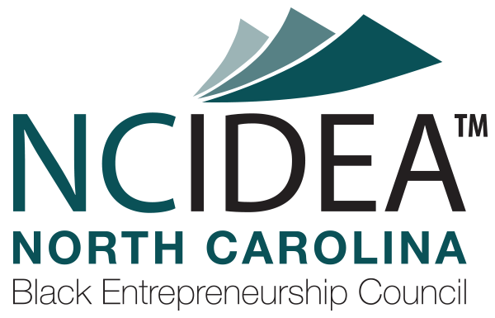

2024 NC BEC ECOSYSTEM

Application Template

IMPORATANT NOTE: The NC BEC ECOSYSTEM grant opportunity is for entrepreneur support organizations that support Black entrepreneurs and Black-owned businesses. This particular grant is not intended to fund the entrepreneurs and businesses themselves. NC IDEA has other grant programs (MICRO and SEED) that directly support startups.

Organizational Information: Please describe your organization, including your mission, geographic scope, and constituents served. (max 2,500 characters)

Team: List the key members of the team that will be involved in executing the proposed program or project. Describe the extent of their involvement and their current role within the organization. Briefly describe each individual’s qualifications and the relevant aspects of their background as it relates to successfully executing the proposed program or project. Does the applicant’s team have deep knowledge of the challenges faced by Black entrepreneurs and/or have proximity to the problem? How does the organization’s executive leadership and board of directors reflect the Black community being served as required by this grant request? What prior successes has the team achieved? (max 1,000 characters)

Proposed Project: Describe your proposed program or project. Be specific. Is this an existing program or project or is it new? Be sure to address to whom this program or project is targeted to impact, and the geographic scope of the proposed program or project. Note that programs or projects supported by this NC BEC ECOSYSTEM grant are REQUIRED to solely focus on helping Black entrepreneurs and growth-oriented Black-owned firms start and grow scalable businesses. (max 7,500 characters)

Alignment: How will the proposed grant outcomes further NC IDEA’s ambition to support North Carolina’s Black entrepreneurs pursuing entrepreneurial opportunities? (max 2,000 characters)

Existing Programs: How has your organization supported Black entrepreneurship in a meaningful way prior to now? Tell us about any related programs you are executing or have executed (if any). Describe concrete results achieved. Are there any similar programs or projects that another organization is currently deploying or working on? (max 1,500 characters)

Total Grant Request ($):

Grant Request and Budget: Provide a summary of the funds being requested for this grant and how they will be used. List budget items, dollar amounts, and projected dates on when the funds will be spent. If you are requesting general operating support, please provide your operating budget. If you are requesting funds that would be disbursed to other parties, but those funds would return back to your organization in some manner, please specifically detail this. If additional funds or resources will be leveraged to complement the proposed program or project, please provide specific amounts and details. Grant requests can be up to but not exceeding $50,000 in total. Grant payments will be disbursed in two tranches; the first in June 2024 and the second by September 30, 2024; with grant activities to be completed prior to June 2025. Funding requests should align with specific activities and may be allocated according to proposed milestones. NC IDEA does not allow grant awards to include indirect overhead costs. (max 2,500 characters)

Outcomes & Metrics: What are the expected outcomes of the proposed program or project? Be specific about what will constitute success. Describe the milestones and metrics the organization expects to reach if a grant is awarded. Milestones should be specific and measurable. (max 2,500 characters)

Leverage: How are your operations currently funded? To what extent would an award from NC IDEA be leveraged by other funds from your organization (or outside financial contributors)? Will other resources complement the proposed program or project? (max 1,500 characters)

Sustainability: How will this proposed program or project be sustained into the future, beyond the timeframe of the grant? (max 1,500 characters)

Impact: Describe how this grant will impact your organization. What additional milestones would this grant enable the organization to achieve? Describe the path that the organization would take if this grant is not awarded. (max 1,500 characters)

MISC: What else should we know about your proposal but failed to ask? (max 1,000 characters)

Recommendation: Did an NC IDEA Employee, Board Member or Member of the North Carolina Black Entrepreneurship Council recommend you apply for the NC BEC ECOSYSTEM grant? If yes, please list their name(s) below.

