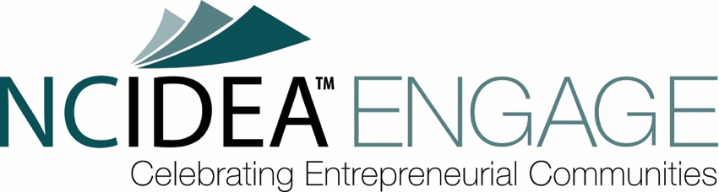
* indicates a required question

First Name*: [text box]
Last Name*: [text box]
Email*: [text box]
Phone Number*: [text box]

Organization Name*: [text box]
Address*: [text box]
Website: [text box]
Social Media Handle: [text box]
Company/Organization Type*: [list] (select LLC, S Corporation, C Corporation, Other (for profit), Nonprofit, Not Incorporated, 501(c)(3)):

Activity Type*: Please select the type of activity that best fits. To see a description of the activity types funded via NC IDEA ENGAGE, please visit https://ncidea.org/nc-idea-engage/ [drop-down menu- Program, Pilot, Event, Student Education, Other]

Activity Title*: [text box]

Organizational Information*: Please briefly describe your organization, including your mission, geographic scope, and constituents served. If you are applying as an individual, please provide a brief bio. Briefly describe your organization's experience in conducting similar activities or programs. Showcase any relevant achievements or successes that demonstrate your capacity to deliver effectively. (max 2000 characters) [text box]

Activity Date(s): To be eligible for funding, your proposed activity must occur at least 60 days from the application submission date. Proposals submitted within 60 days of the desired activity date are less likely to be selected.

By checking the box below, you confirm that your proposed activity will take place at least 60 days from the date of this application submission.

I confirm that my proposed activity will take place at least 60 days from the date of this application submission. [checkbox]

Activity Dates* [text box]

Proposed Activity* Please provide a detailed description of the proposed activity for which you are seeking funding. This description should be clear and concise, addressing the following:

- Activity Type- Briefly describe your proposed activity (e.g., workshop, conference, networking event, pilot program, etc.).
- Target Audience- Who is the intended audience for this activity? Be specific about the types of entrepreneurs or stakeholders you aim to reach.
- Activity Format and Schedule- Describe the format and schedule of the proposed activity. This could include duration, curriculum, speakers, or planned sessions.
- Describe any partnerships or collaborations you have established or plan to support the implementation of the activity. Explain how these partnerships will contribute to the success of the project. (max 2000 characters) [text box]

Grant Impact* Describe the anticipated impact of your proposed activity on the entrepreneurial ecosystem in North Carolina. Be specific and measurable whenever possible. Highlight specific examples of how your activity will address identified needs or gaps within the entrepreneurial ecosystem. (max 2000 characters) [text box]

Activity Location*: [textbox]

Amount Requested (max $5,000)*: [text box]

Total Budget*: [text box]

Use of Funds*- Please provide an estimated breakdown of how the grant will be allocated to fund the proposed activity. Is the NC IDEA ENGAGE Grant the sole funding source, or will it be used with other new or existing funding? What other sources of funding will be leveraged (if applicable)? [text box]

Metrics*: Please provide details on how you will measure the proposed activity’s impact and effectiveness. This includes selecting suggested metrics and submitting your custom metrics. You will be required to report on the number of participants and their satisfaction in the final grant report.

Select 1-2 of the following metrics that best align with your activity's goals*:
  - Network connections- Track the formation of new connections between participants, mentors, investors, or other key stakeholders facilitated by the activity via pre/post-activity surveys or another method.
  - Knowledge/skill acquisition- Measured by pre- and post-activity assessments, surveys, or participant feedback.
  - Cost per participant- help measure program efficiency.
  - Leveraged resources- track any additional resources utilized beyond the NC IDEA ENGAGE Grant (partnerships, sponsorships, etc.).
In addition to the options above, please propose at least two metrics specific to your activity and its unique goals. Be sure to clearly define the metrics and explain the methods you will use to collect data and assess progress toward your stated goals. Describe how you will evaluate the success and impact of your activity. (max 1200 characters) [text box]

Mission Alignment* How will the projected outcomes further NC IDEA’s vision and mission? How do the outcomes relate to NC IDEA’s strategies? Provide specific examples and details to illustrate how your activity aligns with each relevant aspect of NC IDEA's mission. Here are some areas to consider when demonstrating alignment:

- Does your activity directly support or empower entrepreneurs in North Carolina? How will it contribute to their growth and success?
- Does your activity have the potential to stimulate economic activity in the state by supporting startups, such as job creation or new business formation?
- Does your activity contribute to strengthening the overall entrepreneurial ecosystem in North Carolina by fostering collaboration, networking, or access to resources?
- Does your activity promote equity, inclusivity, and accessibility for diverse entrepreneurs and stakeholders within the ecosystem? (max 1000 characters) [text box]

Recommended By Did an NC IDEA Employee or Board Director recommend you apply for the NC IDEA ENGAGE grant? If yes, please list their names below. [text box]

Please list any NC IDEA employee or Board Directors who support (previously or currently) your organization through volunteering on board or committees or through financial contributions. In addition, please indicate the nature of their involvement. [text box]

I acknowledge that NC IDEA reserves the right to maintain all information in this application. By applying to an NC IDEA Program, I recognize that my email and company demographics may be added to the NC IDEA mailing list and, when appropriate, shared with an exclusive list of NC IDEA Partners. If you do not want to be included on the NC IDEA mailing list or you do not want us to share your information with our exclusive partners, you can opt-out by sending an email request to programs@ncidea.org. Please enter your full name below. [text box]

